**Scrum Process Management**

**LOW LEVEL DESIGN**

**Flow Diagram :**

**Process Overview:**

* + - The purpose of this software or project is to show the requirements for the Scrum Process Management which creates a direct contact between Product Owner and Release Manager. And it will provide a efficient and handy Platform for the development of proposed product or software.

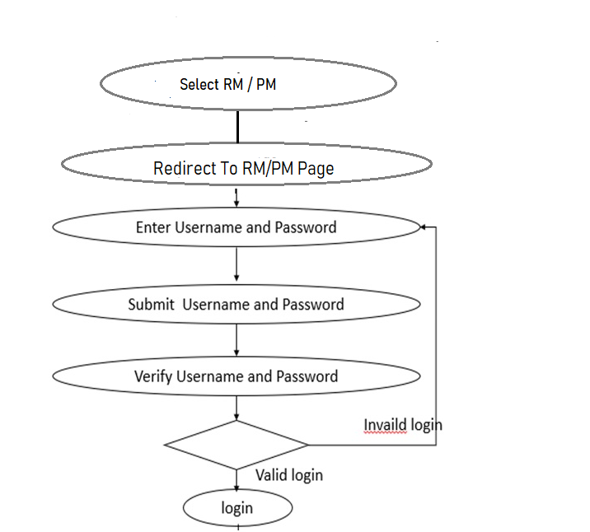**Procedure flow:**

**For User registration:**

The user chooses the category as Release Manager then he/she has to register itself for the authentication process.

After Successful registration, the Release Manager needs to login with the credentials provided during the registration time.

**User Validation For Client:**

The main function is to Compare the entered username and password with registered username and password stored in the data file.

**Procedure flow:**

**Sequence flow:**

**New User:**

The user registration is to be created for Release Manager and the data of the registered user is stored in a file. For login the details from the Release Manager get compared with the data file stored in file.

**Registered User:**

The registered user is to Compare the entered username and password with registered username and password stored in the data file.

**Logout:**

The logout is used to exit from the application by the logged in users. After logged out, the users can also able to login again.